**Program 15:**

1. Write a program to implement the C-SCAN elevator disk scheduling algorithm. The program should give detail about each disk movement from starting head position (input from the user) and calculate average head movement.
2. Write a program to implement the C-LOOK elevator disk scheduling algorithm. The program should give detail about each disk movement from starting head position (input from the user) and calculate average head movement.

**Answer:**

1. Source Code:

#include <iostream>

#include <vector>

#include <cmath>

#include <algorithm>

using namespace std;

int search_(vector<int> programs,int lo, int hi, int x){// find point where arr[mid]<=head && arr[mid+1]>head

if(lo<hi){

int mid=(hi-lo)/2;

if(programs[mid]==x){

return mid;

}else if(programs[mid]<x){

if((mid+1)==(int)programs.size() || programs[mid+1]>x) return mid;

else search_(programs,lo,mid-1,x);

}else{

if((mid)==0 || programs[mid-1]<x) return mid;

else search_(programs,mid+1,hi,x);

}

}

return -1;

}

int piv(vector<int> &arr, int lo, int hi){

int i=lo, p=arr[hi];

for (int j=lo; j<=hi;j++){

if(arr[j]<p){

swap(arr[j],arr[i]);

i+=1;

}

}

swap(arr[hi],arr[i]);

return i;

}

void sort_(vector<int> &arr,int lo, int hi){

if(lo<hi){

int p=piv(arr,lo,hi);

sort_(arr,lo,p-1);

sort_(arr,p+1,hi);

}

}

int left_move(vector<int> programs, int from, int to, int pos){

int sum=0;

for(int i=from; i>=to; i--){

sum+=abs(programs[i]-pos);

cout<<pos<<"\t"<<programs[i]<<"\t"<<abs(programs[i]-pos)<<endl;

pos=programs[i];

}

return sum;

}

int right_move(vector<int> programs, int from , int to, int pos){

int sum=0;

for(int i=from+1;i<=to;i++){

sum+=abs(programs[i]-pos);

cout<<pos<<"\t"<<programs[i]<<"\t"<<abs(programs[i]-pos)<<endl;

pos=programs[i];

}

return sum;

}

int algo(vector<int> programs,int pos,int dir,int disk){

programs.push_back(disk-1);

programs.push_back(0);

int sum=0,diff, n=(int)programs.size();

sort_(programs,0,n-1); //sorting

int ind=search_(programs,0,n-1,pos); //searching nearest index(0 based)

if(programs[ind]>pos) ind-=1;

cout<<"Disk Movement:-"<<endl;

cout<<"From\tto\tDisk Movement"<<endl;

if(dir==0){

// for left side

sum+=left_move(programs,ind, 0, pos);

sum+=left_move(programs,n-1,ind+1,0);

}else{

// for left side

sum+=right_move(programs,ind,n-1,pos);

sum+=right_move(programs,0,ind,disk-1);

}

return sum;

}

int main()

{

int n,pos,dir,disk;

cout << "Enter number of programs\tInitial position of Head\tTotal number of disks"<<endl;

cin>>n>>pos>>disk;

cout << "Enter direction of head movement **1 = Right and 0 = Left**"<<endl;

cin>>dir;

vector<int> programs(n);

cout<<"Enter programs"<<endl;

for (int i=0; i<n;i++){

cin>>programs[i];

}

int total_movements=algo(programs,pos,dir,disk);

total_movements=(float)total_movements;

cout<<"Average disk movement: "<<total_movements/(float)n<<endl;

return 0;

}

Output:

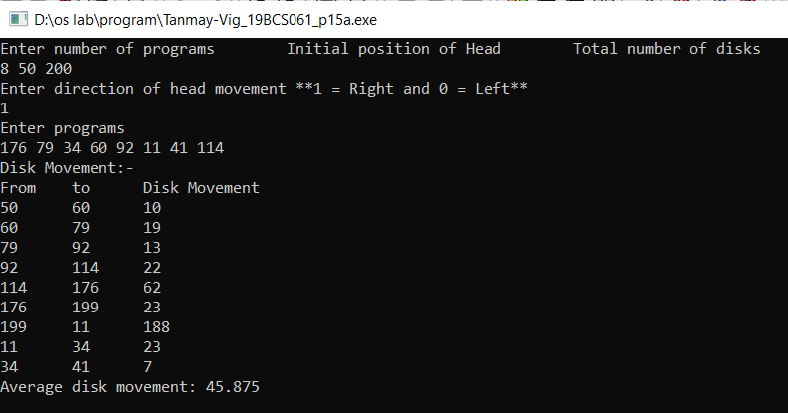

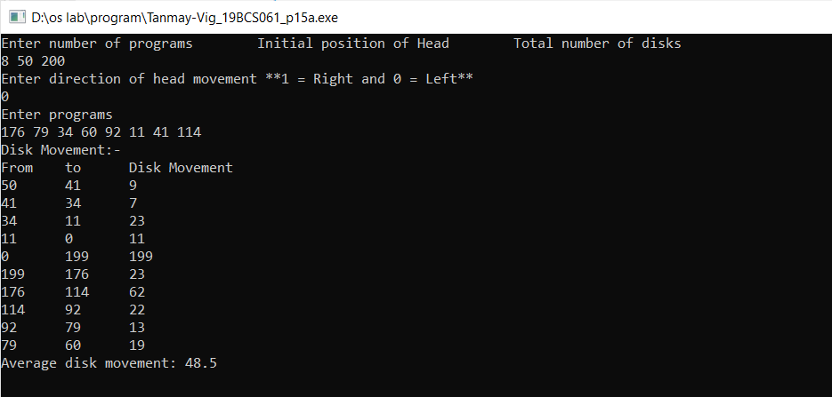

1. Source code:

#include <iostream>

#include <vector>

#include <cmath>

#include <algorithm>

using namespace std;

int search_(vector<int> programs,int lo, int hi, int x){// find point where arr[mid]<=head && arr[mid+1]>head

if(lo<hi){

int mid=(hi-lo)/2;

if(programs[mid]==x){

return mid;

}else if(programs[mid]<x){

if((mid+1)==(int)programs.size() || programs[mid+1]>x) return mid;

else search_(programs,lo,mid-1,x);

}else{

if((mid)==0 || programs[mid-1]<x) return mid;

else search_(programs,mid+1,hi,x);

}

}

return -1;

}

int piv(vector<int> &arr, int lo, int hi){

int i=lo, p=arr[hi];

for (int j=lo; j<=hi;j++){

if(arr[j]<p){

swap(arr[j],arr[i]);

i+=1;

}

}

swap(arr[hi],arr[i]);

return i;

}

void sort_(vector<int> &arr,int lo, int hi){

if(lo<hi){

int p=piv(arr,lo,hi);

sort_(arr,lo,p-1);

sort_(arr,p+1,hi);

}

}

int left_move(vector<int> programs, int from, int to, int pos){

int sum=0;

for(int i=from; i>=to; i--){

sum+=abs(programs[i]-pos);

cout<<pos<<"\t"<<programs[i]<<"\t"<<abs(programs[i]-pos)<<endl;

pos=programs[i];

}

return sum;

}

int right_move(vector<int> programs, int from , int to, int pos){

int sum=0;

for(int i=from+1;i<=to;i++){

sum+=abs(programs[i]-pos);

cout<<pos<<"\t"<<programs[i]<<"\t"<<abs(programs[i]-pos)<<endl;

pos=programs[i];

}

return sum;

}

int algo(vector<int> programs,int pos,int dir,int disk){

int sum=0,diff, n=(int)programs.size();

sort_(programs,0,n-1); //sorting

int ind=search_(programs,0,n-1,pos); //searching nearest index(0 based)

if(programs[ind]>pos) ind-=1;

cout<<"Disk Movement:-"<<endl;

cout<<"From\tto\tDisk Movement"<<endl;

if(dir==0){

// for left side

sum+=left_move(programs,ind, 0, pos);

sum+=left_move(programs,n-1,ind+1,programs[0]);

}else{

// for left side

sum+=right_move(programs,ind,n-1,pos);

sum+=right_move(programs,0,ind,programs[n-1]);

}

return sum;

}

int main()

{

int n,pos,dir,disk;

cout << "Enter number of programs\tInitial position of Head\tTotal number of disks"<<endl;

cin>>n>>pos>>disk;

cout << "Enter direction of head movement **1 = Right and 0 = Left**"<<endl;

cin>>dir;

vector<int> programs(n);

cout<<"Enter programs"<<endl;

for (int i=0; i<n;i++){

cin>>programs[i];

}

int total_movements=algo(programs,pos,dir,disk);

total_movements=(float)total_movements;

cout<<"Average disk movement: "<<total_movements/(float)n<<endl;

return 0;

}

Output:

